Heart of Ruin

Game Design Document
Version 1

Taliesin Games
Contents
1. Game Overview
1.1 Game Title
1.2 Development Team
1.3 Genre
1.4 Target Audience
1.5 Platform(s)
1.6 Elevator Pitch
1.7 Core Concept
1.8 Unique Selling Points

2. Core Gameplay
2.1 Gameplay Loop
2.2 Core Mechanics
2.3 Player Abilities
2.4 Progression

3. Story & World
3.1 Premise
3.2 Setting
3.3 Key Characters
3.4 Narrative Structure

4. Art & Visual Style
4.1 Art Direction
4.2 Character Design
4.3 Environment Design
4.4 UI/UX Style

5. Audio
5.1 Music Style
5.2 Sound Effects
5.3 Voice Acting

6. Technical Requirements
6.1 Engine
6.2 Software Packages
6.3 Tools
6.4 Performance Targets

7. Systems Design
7.1 Economy
7.2 AI Systems
7.3 Difficulty

8. Project Scope
8.1 Team Roles
8.2 Timeline

This document is subject to change throughout the development of this game.

1. Game Overview
1.1 Game Title
Heart of Ruin

1.2 Development Team
Taliesin Games was founded in September 2025 by a group of University of Derby students on the Computer Games programmes. The project was started as part of the Game Development team module and is expected to continue once the degree element has been completed.

Art
Steven Holmes
Claire Peacey
Daniel Sullivan
Daniel Clamp
Programming
David Mulgrew
Callum Streets

Damian Turner

1.3 Genre
Multiplayer Action Roguelite

1.4 Target Audience
Young Adult (20 – 34).
Indie Curious.

1.5 Platform(s)
Primary: PC
Target Platforms: Steam Machine, PlayStation 5, Xbox Series X/S, Nintendo Switch 2.

1.6 Elevator Pitch
Heart of Ruin is a fast-paced multiplayer action-roguelite where players battle through corrupted biomes to recover the lost pages of a shattered spellbook and complete the incantation left unfinished by a fallen wizard. Each recovered page unlocks new options, while a dynamic tension meter heightens risk. Fight the boss on your terms, but push too far, and the biome boss will break free, blending skill-based combat, exploration, and suspense unlike any other game.

1.7 Core Concept
Players take on the role of a member of the guild, continuing the mission of the Wizard, whose life was sacrificed to stop the Heart of Ruin. The wizard’s spell failed, scattering the pages of his tome across corrupted lands. Each recovered page unlocks new abilities and progression options.

1.8 Unique Selling Points
- Dynamic Tension System: The tension meter responds to collective player actions; high tension triggers boss engagement, forcing teams to manage risk and strategy together.
- Integrated Narrative & Mechanics: Progression directly impacts story and spell completion.
- Cooperative Spellbook Reconstruction: Players work together to collect scattered pages, unlocking unique group-based spells, abilities, and combos.
- Corrupted Biomes as Active Threats: Each biome reacts dynamically to player actions, with environmental hazards and AI-controlled monsters scaling with party size.
- Skill Forward Cooperative Combat: Combat rewards both player skill and progression. Players can coordinate dodges, spells, and attack combos, while upgrading stats and abilities to increase their effectiveness. A variable skill ceiling allows beginners to contribute meaningfully, whilst giving experienced players opportunities to master advanced combos, strategy, and timing.
- Safe Haven Multiplayer Hub: Shared safe point where players can trade, craft, fast travel between biomes, form parties, and engage with narrative elements. A central space for planning, social interaction, and preparation between runs.
2. Core Gameplay
2.1 Gameplay Loop
Run > Kill Boss > Recover Pages > Return to Safe Haven > Upgrade > Repeat.

2.2 Core Mechanics
Each run challenges players to balance aggression and caution as the tension gauge rises, pushing the risk–reward dynamic. Progress persists across runs through spellbook reconstruction, character growth, and equipment, encouraging mastery and experimentation.
- Tension System: Actions increase biome tension. Reach maximum tension and the boss breaks free, forcing an immediate encounter.
- Cooperative Multiplayer (1–4 players): Players coordinate attacks, revives, utility, and synergy-based ability combos.
- Roguelite Progression: Persistent advancement through unlockable abilities, stats, heroes, and spellbook upgrades.
- Spellbook Reconstruction: Recover pages to complete the unfinished incantation left by the Wizard, unlocking new mechanics and long-term meta progression.
- Safe Haven Hub: Shared multiplayer camp for trading, crafting, upgrades, fast travel, and narrative delivery.

2.3 Player Abilities
- Basic Movement: Move, dodge, and reposition quickly in and out of combat.
- Melee Combat: Perform close-range attacks using melee weapons of varying speed and power (1H/2H Weapons)
- Ranged Combat: Engage enemies from a safe distance.
- Magical Combat: Wield magical weapons or abilities, allowing variation of magical attacks that compliment melee and ranged attacks.
- Co-op Interactions: Assist each other, revive allies, and create combination spell synergies.
- Environmental Interaction: Activate key objects, cleanse corruption at points of interest, or collect spell fragments.

2.4 Progression
- Run-based progression: Players grow stronger during each successful run by collecting weapons, magical abilities, and artifacts.
- Spellbook Pages: Recovering lost pages unlocks new abilities and permanent stat upgrades for future runs.
- Character Growth: Players can enhance stats like health, mana, strength, dexterity, and intelligence.
- Team Synergy: Some upgrades improve cooperative effects, encouraging multiplayer gameplay.
- Meta-progression: Over multiple runs, players can unlock new classes, abilities and passives that persist between sessions.

3. Story & World
3.1 Premise
The veil of reality has been torn apart. From the rift came a god of malice, unleashing a singularity. The vortex of corruption siphons lifeforce and magic, leaving only ruin.
In desperation a lone wizard stood against this darkness, hoping to bind the corruption. But the spell failed. His body was torn asunder, his tome shattered, its pages scattered across the world.
Now, the Heart of Ruin pulses at the centre of creation’s decay. You must venture into its ever-changing depths, battling corruption to recover the lost pages of the wizard’s tome.
Seek refuge in the divine-sanctified haven, where you rest, plan, and prepare. Beyond its walls lie shifting domains, teeming with monsters, traps, and forgotten magic. Every descent is perilous, every page vital. The fate of the world hangs in the balance.

3.2 Setting
Heart of Ruin takes place in a fantastical world torn apart by the rift of corruption. The environment is dynamic and ever changing, with biomes that shift and mutate, reflecting the spread of God of Malice’s influence.
Players will explore corrupted forests, desolate wastelands, and arcane infused landscapes, each teeming with monsters, traps and hidden magic. At the centre of it all lies the Heart of Ruin, a pulsating core of decay that drives the corruption throughout. Safe Havens serve as respites where players can rest, plan, and prepare before venturing into the perilous unknowns ahead.

3.3 Key Characters
The Lone Wizard – NPC.
A legendary figure and founder of the guild, devoted to maintaining balance between life and magical forces. Though he no longer exists in physical form, his presence is felt through the scattered pages of his shattered tome. These relics contain fragments of a spell powerful enough to contain the Heart of Ruin. The Wizards’ teachings, strategies and vision continue to guide the player, who as his successor carries the responsibility to rebuild the tome, speak the incantation, and confront the corruption.
Born in an era of fragile balance between nature and magic, the Wizard displayed great talent from a young age. He founded the guild to protect knowledge and life, training disciples in the responsible use of magic. When the god of malice unleashed the singularity, he attempted a spell to contain it, but the ritual failed, destroying the wizard entirely.
His sacrifice and teachings define the standard for all successors, and every recovered page brings the world one step closer to its salvation.

The Elf – Player Character.
A young, female elf from the mystical Verdant Glade, a secluded forest rich with magical flora and ancient trees. Slim, graceful and agile, she embodies the typical elven physique, adorned in lightweight, flexible armour and natural accessories that reflect her connection to nature. Her bright, expressive eyes and flowing hair convey both curiosity and affinity with the living world.
Trained and mentored by the Wizard, she learned a fragment of his magic that harmonises with life, alongside survival, combat and exploration skills. When the Heart of Ruin shattered the world, corrupting the lands and twisting creatures into monsters, she set out to recover the scattered pages of the Wizards spellbook. Driven by empathy, curiosity, and a sense of duty, she ventures into corrupted zones, battling the spreading darkness and striving to restore balance.
Her skill with weapons, agility, and magical abilities makes her a formidable force through a world where nature itself has turned against her.

The Human – Player Character.
A middle-aged warrior born into a family with a long tradition of service to the crown. Muscular and battle hardened, he wears practical armour and carries a weapon of choice, marked with the scars and experience of decades of combat. Calm, disciplined, and tactical, he prioritises action over words and acts according to a strict code of honour.
Raised with the Royal Guard, he trained in combat, strategy, and loyalty from childhood. His path crossed with the guild through missions that aligned with his duty to protect the kingdom. When the Heart of Ruin spread corruption, he partnered with guild members to confront the threat, applying his experience, discipline, and unwavering resolve. Though independent in method, he shares the guilds goals, protecting the innocent and facing corruption head-on while embodying the principles of courage, duty and steadfastness.

3.4 Narrative Structure
Heart of Ruin uses a run-based narrative where the overarching story unfolds through exploration and recovery of the Wizards tome pages. The narrative structure combines persistent story with run events.
- Story Progression
  - The worlds state changes as players recover pages, gradually revealing more of the history and background.
  - Successive runs unlock new abilities, areas, and lore, connecting the player’s actions to long term world restoration.
- Run-Based Narrative
  - Each descent into the Heart of Ruin is a self-contained story segment, presenting unique challenges, events, and encounters.
  - Players interact with corrupted creatures, environmental hazards, and hidden secrets whilst recovering spell pages.
  - Optional narrative events may reveal character backstory, guild lore, or fragments of magical knowledge.
- Character Development
  - Character growth through gameplay, reflecting their increasing mastery, understanding of the corruption, and their relationship to the Wizard.
  - Player choices during exploration, combat, and interaction influence character development and unlock optional narrative content.
- Endgame
  - As the tome is reconstructed, players gain the knowledge and power to confront the God of Malice directly.
  - The final confrontation is a combination of strategic combat, learned abilities, and narrative resolution culminating in the restoration of balance throughout the world.

4. Art & Visual Style
4.1 Art Direction
Overall Aesthetic
The games overall aesthetic blends illustrative stylised fantasy art with dynamic high-clarity action readability. The visual identity pulls Dofus’ whimsical charm, while incorporating the bold, energetic presentation of games like Hades. Environments, characters, and effects are designed with a hand-painted, slightly exaggerated look, prioritising shape language and colour harmony.
The world feels vibrant, magical and alive. Organic shapes and flowing silhouettes create a sense of natural beauty within the Wildwood Biome. Magical corruption, glowing flora and other bioluminescence break up the natural palette, reinforcing the theme of a forest saturated with corruption and arcane energy.
Influences and References
Heart of Ruin is influenced by several key titles.
Dofus - established baseline art style for environments.
- Clean and simple art style.
- Exaggerated but charming.
- Warm, painted colour palettes.
Hades – ensures the games combat remains visually exciting and readable.
- High contrast.
- Strong, iconic silhouettes.
- Vibrant, reactive VFX.
- Dynamic.
Curse of the Dead Gods – strengthens magical corruption theme whilst maintaining a painted aesthetic.
- Heavy directional lighting to carve silhouettes.
- Stylised shadows to shape room mood.
- Torchlight, magical flames, and colour driven illumination.
Ori and the Blind Forest – defines the magical essence of the Wildwood biome.
- Bioluminescent flora.
- Layered backgrounds with soft glows.
- Mystical light beams and atmospheric fog.
- Uses colour to convey environmental emotion.
Traditional Folklore Art & Illustrations adds real world historical elements to a stylised fantastical world.
- Knotted roots, winding branches.
- Forest spirits and mystical fauna.
- Organic motifs.
- Mystical and folklore creatures.
Lighting Style: TBC – This is a suggestion!
Heart of Ruin blends stylised soft illumination, dynamic contrast, and directional mood lighting. The result is a whimsical yet treacherous atmosphere that reinforces the mystical dangers of the Wildwood.
During combat, lighting shift to high contrast, rim-lit silhouettes, highlighting the player and enemies using bright accentuated colours for visualisation. This ensures fast action remains clear without losing the painted style.
The Heart of Ruin itself is a purple black “black hole” shader that spreads a low opacity fog over nearby terrain. Its pulsing glow tints the environment, adding subtle lighting to nearby objects and creatures, signalling corruption and danger. Despite this overlay, silhouettes and gameplay elements remain highly readable through controlled fog intensity, opacity and contrast.
Tone & Atmosphere:
The wildwood biome embodies a dual nature; vibrant and alive on the surface yet haunted by deep-rooted magic that corrupts it to its core. This balance between charm and menace defines the overall emotional experience.
The forest itself feels alive and reactive. Magic, glowing spores, and bioluminescent flora light the environment. Despite its beauty, the Wildwood carries a constant sense of unease. Twisted roots obscure paths, corruption hums with unstable energy, and the light behaves strangely.
The atmosphere aims to establish a world where magic is beautiful but volatile, and every part of the forest, flora and fauna contributes to a sense of wonder and danger simultaneously.

Colour Palette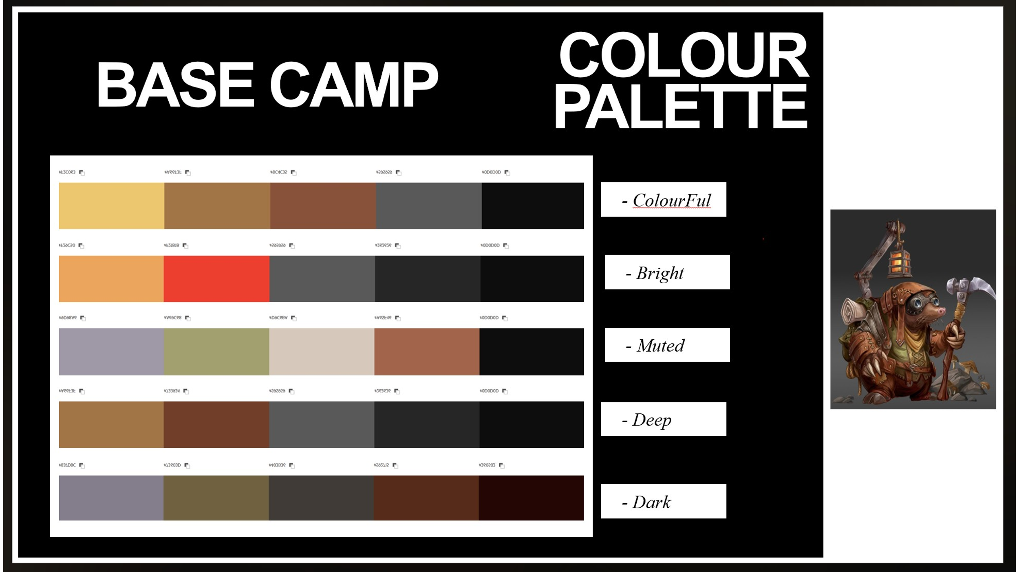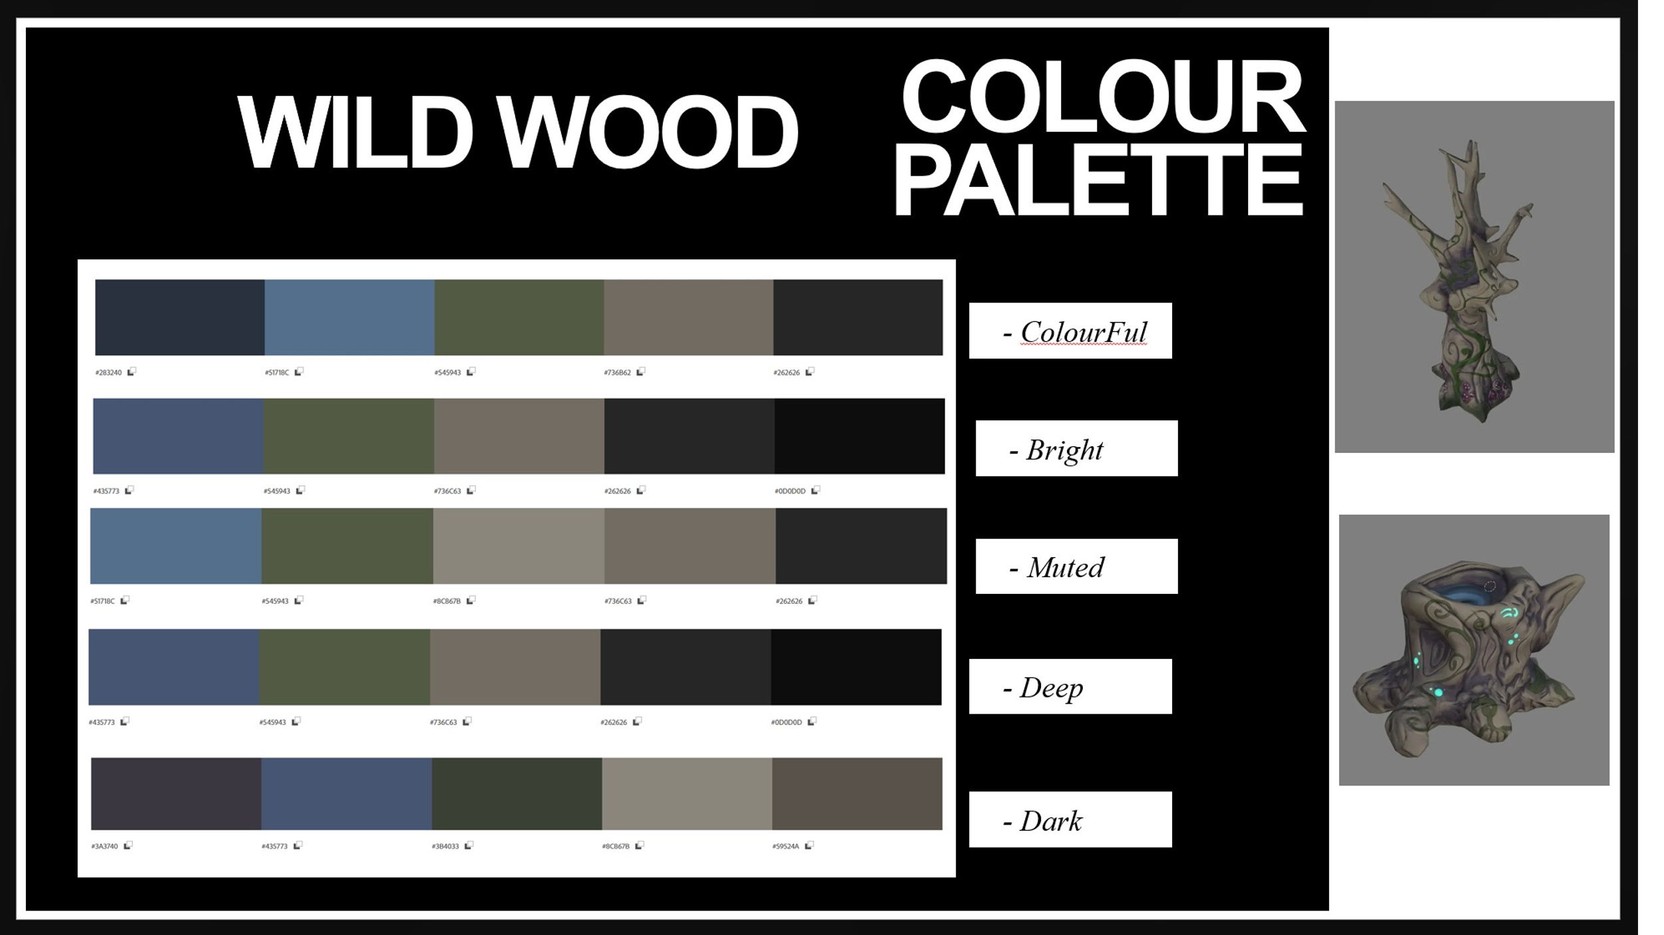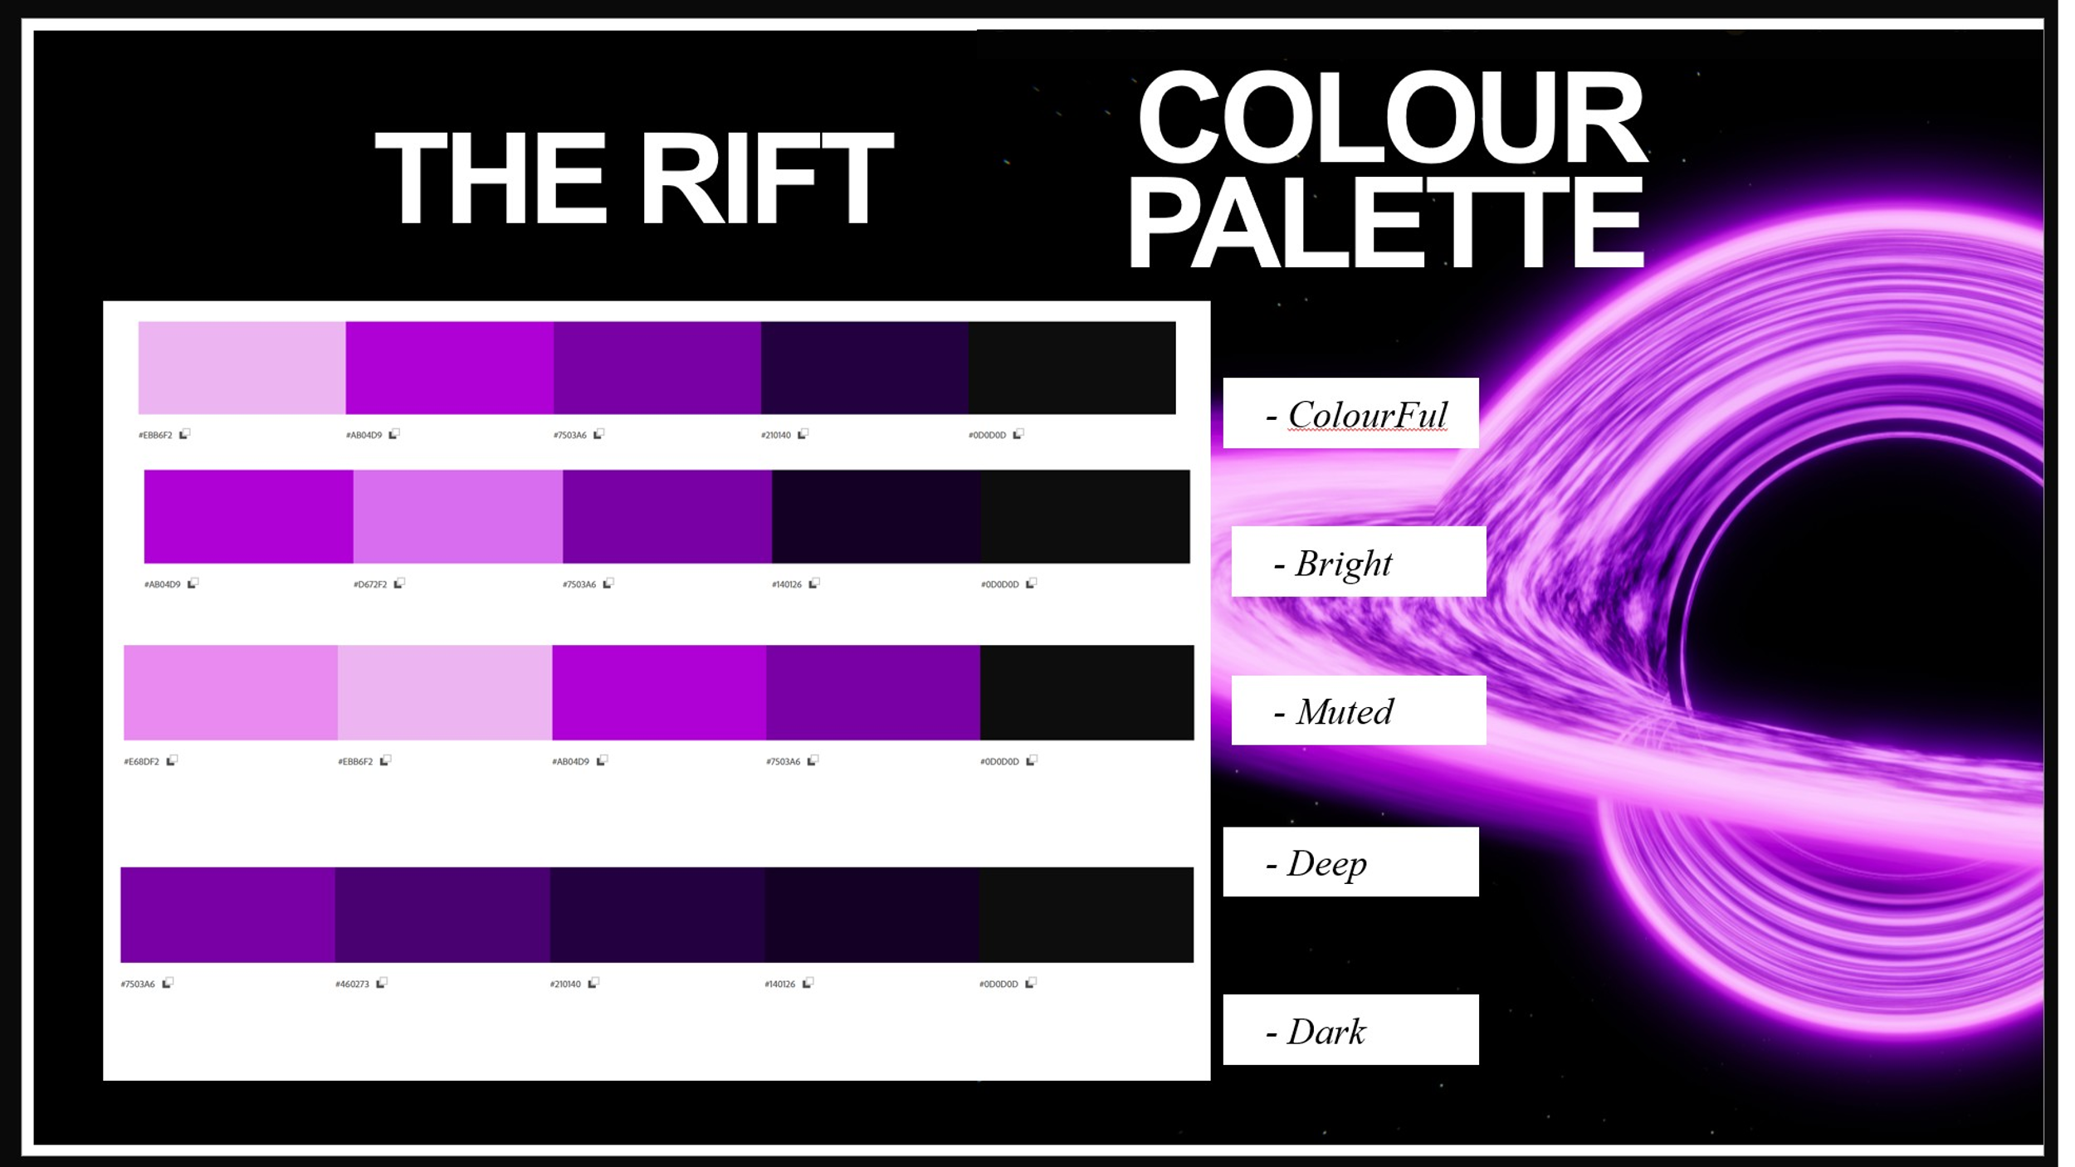
4.2 Character Design
Character design balances charm, readability and visual storytelling. Silhouette clarity, contrasting colours and expressive details are critical to make each character instantly recognisable.
All character profiles are located in Taliesin Games GDD Documentation.

Elf Player
Build: Slim, graceful, agile. Typical elven physique.
Height: Slightly taller than human females, reflecting elven proportions.
Hair: Long, flowing, perhaps silver, blonde, or deep auburn. Natural, with hints of subtle braiding or adornments from her enclave.
Eyes: Bright and expressive green, amber, or blue. Reflecting her connection to nature.
Clothing/Armour:
- Lightweight, flexible armour or layered tunics allowing freedom of movement.
- Natural materials like leather, cloth, decorated with mystical patterns.
- Practical for forest exploration and combat, but still distinctly elven.
Accessories / Signature Traits:
- A small pendant, circlet, or armband with motifs of leaves or animals. Perhaps a gift from the wizard.
- Subtle marks or tattoos symbolising her connection to the natural world.
Personality:
- Deeply connected to nature, empathetic toward living creatures and the natural world.
- Curious, observant, and patient, but still carries youthful energy and daring.
- Intelligent and perceptive, with a natural inclination toward understanding magical and ecological balance.

Mole Trader NPC
Size & Shape: Large mole, roughly 2 metres tall, but only the top half is visible behind a stall or counter. Broad shoulders, stout torso, short arms resting on the counter.
Texture & Material: Dark, earthy fur with streaks of grey. Thick claws slightly shiny, hinting at its digging nature.
Colour Palette: Earth tones browns, muted blacks, and greys.
Face / Features: Round snout with a twitching nose, small bright eyes full of intelligence, short, rounded ears. Gentle expressions convey curiosity and friendliness.
Accessories / Detail: Shelves or bags behind the counter for storing wares. Magical trinkets or glowing crystals hang from belts. Occasionally, a small lantern or crystal glows on the stall.
Movement: Mostly stationary, small gestures like leaning forward, adjusting items, or twitching nose and whiskers.

Stump Folk Enemy
Size & Shape: Knee to waist height. Cylindrical body with roots for legs.
Texture & Material: Rough, gnarly bark with knots, and twists.
Colour Palette: Dark earthy browns with faded greens from moss.
Face / Features: Crude, carved-like face. Two knot holes for eyes, a shallow groove for a mouth.
Accessories / Detail: Small patches of moss, or tiny mushrooms on shoulders/tops. Some stumps may have broken branches, leaves, or forest debris.
Movement: Slow, shuffling from side to side, deliberate.

Leshy Enemy Elite
Size & Shape: Humanoid 2-3 meters tall. Long limbs made of twisted bark, with branch-like fingers and antler-like projections on its head.
Texture & Material: Rough, knotted bark covering its body, with hanging moss, lichen, and small fungi patches.
Colour Palette: Deep earthy browns, muted greens, with faint veins of corruption glowing through.
Face / Features: Hollowed eye sockets that faintly glow, no mouth movement, expressionless and stoic.
Accessories / Detail: Antler-like branches adorned with vines, broken twigs, and occasional leaves.
Movement: Slow, deliberate, and slightly swaying like a tree in the wind. Attacks are deliberate, long arcs.

Treeant Enemy Boss
Size & Shape: Colossal, humanoid tree form, roughly 6-8 metres tall. Massive trunk-like torso, thick root legs, and enormous branch-arms.
Texture & Material: Deep, ancient bark, cracked and gnarled with moss, lichen, and patches of fungi. Veins of corrupted energy pulsing along its limbs and trunk.
Colour Palette: Dark earthy browns, faded greens, corruption glowing from fissures in its bark.
Face / Features: Hollow eye sockets glow, mouth a jagged, vertical fissure, giving it a permanent grimace.
Accessories / Detail: Hanging vines, broken branches, and corrupted flora clinging to its frame. Roots trail slightly behind as it moves.
Movement: Slow and deliberate, yet every swing and stomp carries immense weight. Branch-arms lash in long, sweeping arcs. Trunk can slam the ground to create shockwaves.

4.3 Environment Design
Environment design balances creating biomes that feel believable whilst remaining visually engaging. Strong composition, lighting and environmental detail will support gameplay and level navigation.
All environment references and biome information can be found in Taliesin Games GDD Documentation.

Procedural Generation
One of the unique selling points of this game will be the introduction of procedural generation for the biomes. No two playthroughs will be the same, adding diversity and replayability for players.

Wildwood
Bio: The Wildwood was once a sprawling forest of ancient trees, moss covered roots, and whispering winds. Now, the Heart of Ruin pulses at its centre, warping everything it touches. Once a sanctuary of balance and natural beauty, corruption transformed the Wildwood into a test of survival and resolve. Creatures once at peace, determined to rid the world of hope.
Terrain and Structure: Ancient trees, their gnarled branches twisting unnaturally under corruption. Canopy cover is dense, casting long shadows even at midday.
Ground: Moss, fungus, and twisted roots. Fallen branches and vines create natural obstacles. Large crystals scattered throughout the landscape.
Light & Atmosphere: A muted green-brown haze pervades the forest, with occasional glowing corruption veins running through trunks and roots. Light filters weakly through the canopy, creating eerie patterns.

Frozen Tundra
Bio: The Frozen Tundra was once a land of snow and crystal lakes, untouched by corruption. Now, an endless winter draining warmth and hope from those who wander too far. Ancient beasts and frozen spirits roam the frozen wasteland, hunting anyone foolish enough to disturb its silence.
Terrain and Structure: Endless snow and ice fields, frost covered crystal and stones. Deep snow in places slow movement. Abandoned camps and half buried ruins scattered across the landscape. Massive icicles hang from cliffs and tree branches.
Ground: Ice, frost-covered floor. Deep snow in places. Corruption protrudes from beneath the surface.
Light & Atmosphere: Pale blue light reflecting across the landscape, creating a cold, lifeless glow. Frost-laced winds carry distant whispers through the land.

Infernal Cavern
Bio: Deep beneath the surface lies the Infernal Cavern. A large underground network of caverns, rich with crystal formations and creatures born to withstand the unbearable heat. Corruption penetrated its volcanic depths, turning magma and shadows to stalk the tunnels. The cavern groans to anyone who dares to enter, for something twisted lurks inside.
Terrain and Structure: Large chambers, with blackened cliffs, collapsed tunnels and towering crystals. Large magma rivers flow through the area.
Ground: Cracked stone, layers of glowing magma veins. Bright red flamelike crystals. Pools of lava illuminate the landscape.
Light & Atmosphere: The cavern glows with deep reds and fiery orange/yellows. Thick smoke and drifting embers fill the air, whilst shadows move across the area.

4.4 UI/UX Style
The user interface will be fantastical by design. The core mechanic of the game is to build the wizards spellbook to be able to complete the incantation and rid the world of corruption. To this end, the spellbook will form the basis of the UI/UX. The codex will contain all progress of the game, and each option window will open like a scroll. Health and Mana will be displayed in potion bottles, containing fluids which will increase or decrease accordingly. The scrolls will be old paper-like, light brown, and the buttons will be green and purple.

5. Audio
5.1 Music Style
Fantasy based classical music, which changes from zone to zone.
Wildwood: Flutes, clarinet, soft horn.
Frozen Tundra: Violins, French horns, chimes and percussion.
Infernal Caverns: Cellos and Basses. Drums, repeated echoes.

5.2 Sound Effects
Royalty free sounds effects will be used. The list of sounds will be ongoing, but initial sounds considered:
- Sword Swipes, Bow and Arrow
- Screams, Groans and Roars.
- Elementals sounds for casting.
  - Lightning Bolts
  - Fireballs
  - Frozen Winds
- Death Noises

5.3 Voice Acting
Several members of the team will do voice overs to save on cost. No professionals will be considered at this stage. Claire Peacey will narrate for the initial game pitch and trailers. The remaining team members will assist with voices for characters.
- Claire Peacey
- Daniel Clamp
- David Mulgrew
- Steven Holmes

6. Technical Requirements
6.1 Engine
Heart of Ruin will be created using Unity Engine 6.

6.2 Software Packages
In addition to Unity Engine the following software packages will be used:
- Adobe Photoshop
- Adobe Premiere Pro
- Adobe Substance Painter
- Adobe Substance Designer
- Autodesk Maya
- Autodesk MotionBuilder
- Blender
- Vicon Shogun Live
- Vicon Shogun Post
- ZBrush

6.3 Tools
All tools will be created in house by the programming team for use in creation of this project. More information can be found in the Taliesin Games GDD Documentation Folder.

6.4 Performance Targets
The expected minimum performance targets are:
- 60 frames per second at 4K resolution.
- Multiple enemies on the screen at the same time.

7. Systems Design
7.1 Economy
The economy in game will be coins and gems. Coins can be used to buy new equipment, and gems will be used to upgrade equipment, add magic properties and to buy luxury / rare items from the Mole Trader.
On death any coins collected during the run will be lost. Gems will not be lost on player death. This ensures progression in game will be possible for all player abilities.

7.2 AI Systems
The enemy AI will be designed to pursue the player in waves, as the player enters each room of the biome. Dependant on the level of the zone, the biome modifiers, and other factors such as players curse, the AI will react accordingly, potentially overwhelming the player.
The boss enemy will start in the boss room, which must be located by the player. This room can be opened early by the player, at risk of premature death. But waiting too long the enemy boss will break free of the room and proceed to hunt the player with bonus modifiers.

7.3 Difficulty
The game will follow other rogue lite games in its difficulty curve. The initial levels will be beginner friendly, but the difficulty will ramp up significantly over time, requiring the player to play multiple playthroughs to be able to find all pages of the spellbook.
Curse modifiers are a selectable option when a player respawns, adding an extra layer of punishment for players wanting a harder experience.

8. Project Scope
8.1 Team Roles
Steven Holmes – Environment Artist / Project Lead.
David Mulgrew – Programming / Deputy Project Lead.
Callum Streets – Technical Artist / Programming.
Claire Peacey – Environment Artist / UI/UX.
Damien Turner – Character Artist / UI/UX.
Daniel Sullivan – Character Artist / VFX.
Daniel Clamp – Worldbuilding / Animation / Rigging

8.2 Timeline
Game Pitch Submission – 8th December 2025
Alpha Presentation & Submission – 20th March 2026
Beta Presentation (Formative) – 11th May 2025
Gold Presentation & Submission – 22nd May 2025

